1. 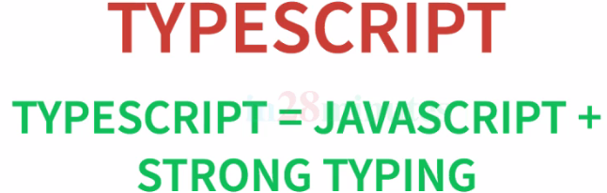
2. 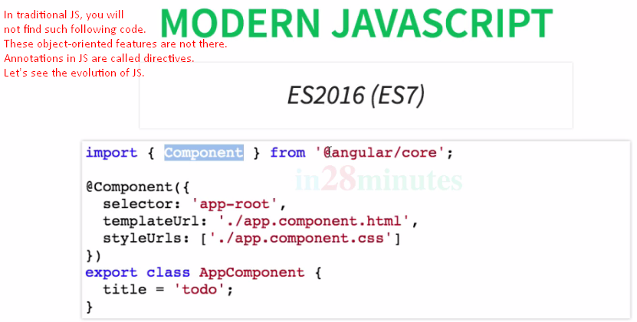
3. 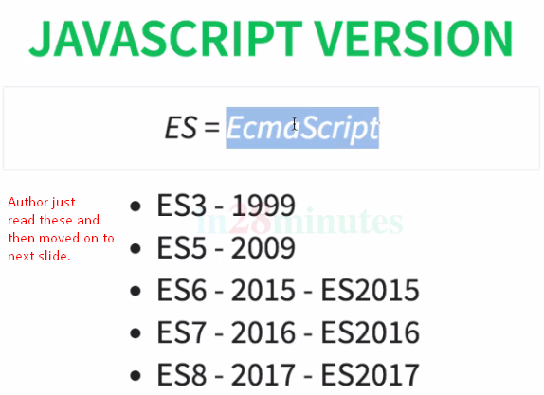
4. 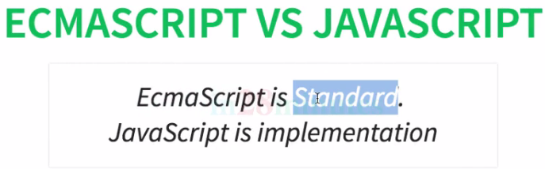
5. **Modern JavaScript**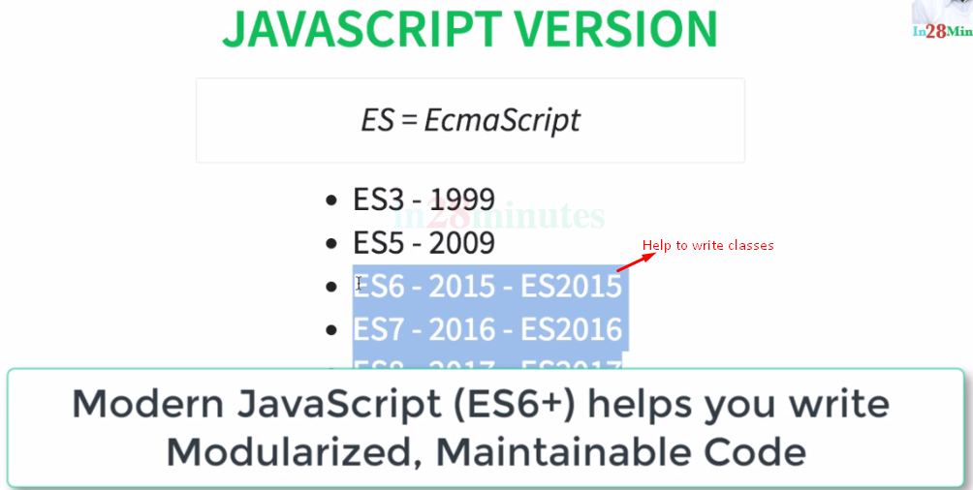
6. The year in which ECMAScript standard has been released is also used to represent the version.   
   So, ES6 (**Standard**) whereas ES2015(**Version**)
7. 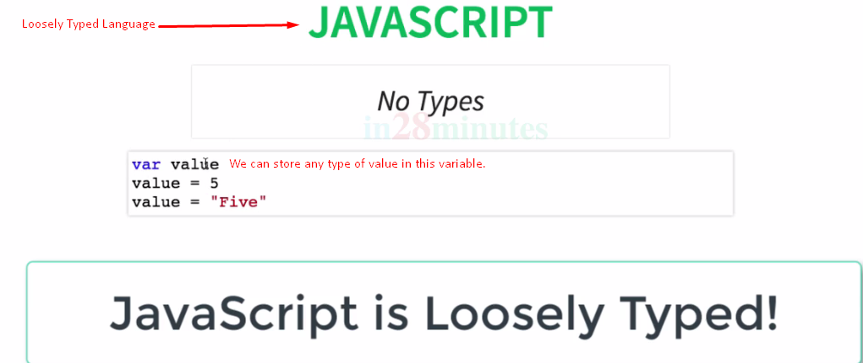
8. 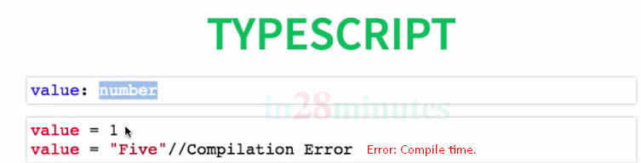
9. 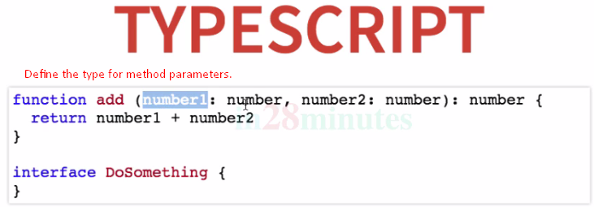
10. **TypeScript has the following features**:
    1. Class, Constructor, Decelerator, Interface, Implementation,
11. Modern JavaScript helps us to write maintainable code using classes, modules, decelerator, and a wide variety of other features.
12. TypeScript helps us to find out errors during compile time by adding strong types to JavaScript.